**Project proposal for DST & Texas Instruments Inc.**

**India Innovation Challenge Design Contest 2017**

**Anchored by NSRCEL, IIM Bangalore**

**<Smart Water Billing System>**

**<Ramaiah University of Applied Sciences>**

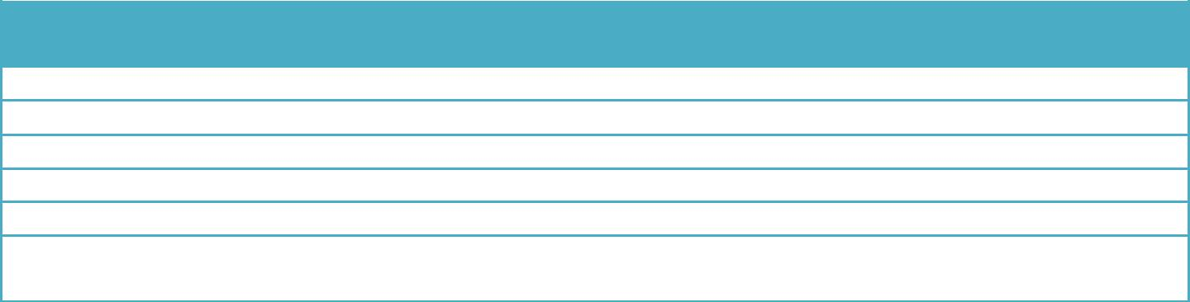

**Name** **College ID/Roll UG/PG Course/Branch Semester**

**No.**

**SHRIDHAR HEGDE 16ETCS002124 UG CSE/’C’ 3**

**SANTOSH G 16ETCS002112 UG CSE/’C’ 3**

**ASHISH KUMAR 16ETCS002144 UG CSE/’C’ 3**

**CHINMAYA GAYATHRI 16ETCS002401 UG CSE/’C’ 3**

**KAVYA S 16ETCS002147**

**Mentor - Mr. PRAKASH P**

**Mandatory Supporting Document [to be added along with proposal]**

* Teams to provide a scanned copy of the college ID of all the team members, **OR**,
* A scanned copy of the letter from College duly signed and sealed by HOD/Faculty Mentor identifying all team members as students of the college

*Note:*

1. *Suggested Length of project proposal – 6-7 pages*
2. *Teams to ensure that the information provided is not plagiarized and all sources are acknowledged in the proposal.*

**Project Abstract**

Teams must provide an abstract about 100 to 150 words summarizing your idea/problem being solved

***Keywords— <as applicable>***

**Team Members – Roles & Responsibilities**

Teams must share the list of all members and explain their role in the team as per following category

* Marketing
* Technical,
* Operations, &
* Any other role(s) as applicable

Teams to provide justification for each team member's role and cite examples as required to support your reasoning.

|  |  |  |  |
| --- | --- | --- | --- |
| **S.No.** | **Student** | **Role (Choose one of the** | **Justification** |
|  | **Member** | **following – Marketing,** |  |
|  | **Name** | **Technical, Operations &** |  |
|  |  | **Other Roles as** |  |
|  |  | **applicable)** |  |
| 1 | SHRIDHAR HEGDE |  |  |
| 2 | SANTOSH G | DEVELOPER | Well versed with programming from childhood |
| 3 | KAVYA S | TESTER | Studied programming from primary school itself |
| 4 | CHINMAYA GAYATHRI | DESIGNER | Well versed with electronic components and electrical systems |
| 5 | ASHISH KUMAR | MARKET RESEARCH | Enthusiast in |

**Market Analysis**

Teams to provide a detailed study about the customer needs [in context of India] leading to identification of the problem being solved which covers the Total Addressable Market (TAM), Serviceable Addressable Market (SAM), study of existing solutions [Competition] and opportunities for enhancing/improving the solution leading to the proposed solution.

Teams to validate their analysis with using graphs, illustrations and quantitative data from different sources as applicable.

1. Customer Need Identification - <Teams to present thier case & Share information>
2. Serviceable Addressable Market (SAM) Identification & Justification - < Teams to share details of their SAM and support with analysis as applicable>
3. Product Differentiation w.r.t. Competition & Justification - < Teams to Highlight the differentiated featues of their product w.r.t. to completion/existing product with justification>
4. Understanding of your customer & user- < Teams to identify their customer & user and share their product positioning to enable ease of adoption for both of these >

***Note:*** Users refer to people using the product/service, and a customer is one whopays for the product/services***. Depending on product both could be same or*** ***different.***

1. Distribution Channel Identification - < Teams to share how would you deliver the product/service to the customers/users>

**Proposed Design**

1. Objective - <*Teams to* share their proposed solution in brief>
2. Proposed Solution
   1. Block Diagram - A clear block diagram highlighting all the subsystems and supported with a detailed explanation for each block/subsystem.

Teams to share all relevant circuit diagrams, any simulation results, and details of any software algorithms to support your proposed solution. Teams are encouraged to use WEBENCH for power designing power supply.

1. Component Used - List all the TI Parts and non-TI parts to be used in designing the proposed solution

|  |  |  |  |  |
| --- | --- | --- | --- | --- |
|  | TI Part Number |  | How is it being used in the proposed solution? Explain |  |
|  | (link all the parts to |  | its role/functionality |  |
|  |  |  |  |
|  | their respective |  |  |  |
|  | product page on the |  |  |  |
|  | TI website) |  |  |  |
|  |  |  |  |  |
| For eg –  [**L293**](http://www.ti.com/product/L293D)**D** | | |  |  |
|  | | |  |  |
| Part 2 | | |  |  |
|  | | |  |  |
| Part 3 | | |  |  |
|  | | |  |  |
| Part 4 | | |  |  |
|  | | |  |  |
| Part 5 | | |  |  |
|  |  |  |  |  |

|  |  |
| --- | --- |
| Non - TI Parts | How is it being used in the proposed solution? Explain |
|  | its role/functionality |
|  |  |
| For eg – 16x2 LCD |  |
|  |  |
| Part 2 |  |
|  |  |
| Part 3 |  |
|  |  |
| Part 4 |  |
|  |  |
| Part 5 |  |
|  |  |

**Innovativeness of the Proposed Solution**

Teams have to explain the uniqueness/differentiation of their proposed solution with respect to the existing competition in the current scenario. Teams can differentiate their proposed solution on the following vectors – size, power, performance, cost, functionality & others as applicable

**Impact of the proposed solution**

Teams have to explain the impact of their proposed solution on the customer/relevant industry and Justify with data as applicable.